Requirement Analysis

Group ict1.k62s.20201-09

* Phạm Văn Khoa

# Use case diagram

## General use case diagram

Description of actors …

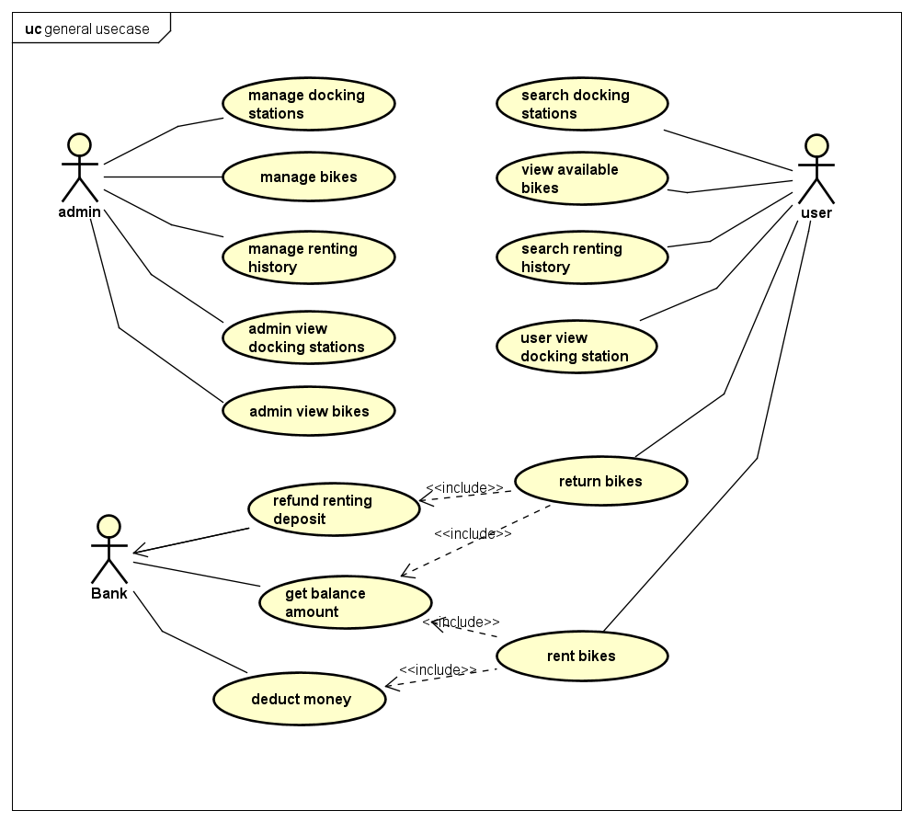

## C:\Users\LaptopAZ.vn\AppData\Local\Microsoft\Windows\INetCache\Content.Word\Return bikes.jpgUse case diagram for “Return bikes”

# Use case specification

## Use case “Insert Credit Card Number”

|  |  |  |  |
| --- | --- | --- | --- |
| UC Code | UC001 | Use case name | Insert Credit Card Number |
| Actor | User | | |
| Precondition | Choose Docking Station | | |
| Main flow of event  (success) | |  |  |  | | --- | --- | --- | | # | Doer | Action | |  | User | Press “Return bike” button. | |  | System | Display “Please insert credit card number”. | |  | User | Insert credit card number. | |  | System | Refund deposit money. | |  | System | Check balance. | |  | System | Deduct renting money. | |  | System | Display “Return bike successfully” | | | |
| Alternative flow of event | |  |  |  | | --- | --- | --- | | # | Doer | Action | | 2a. | System | Display error: You don’t have any bike rented. | | 3a. | System | Display error: Invalid credit card number. | | 6a. | System | Display error: Insufficient balance. | | | |
| Post condition | No | | |

* Credit card number input requirement:

|  |  |  |  |  |  |
| --- | --- | --- | --- | --- | --- |
| **#** | **Data field** | **Description** | **Required?** | **Valid condition** | **Example** |
|  | Credit card number |  | Yes | Only digits | 123456789 |